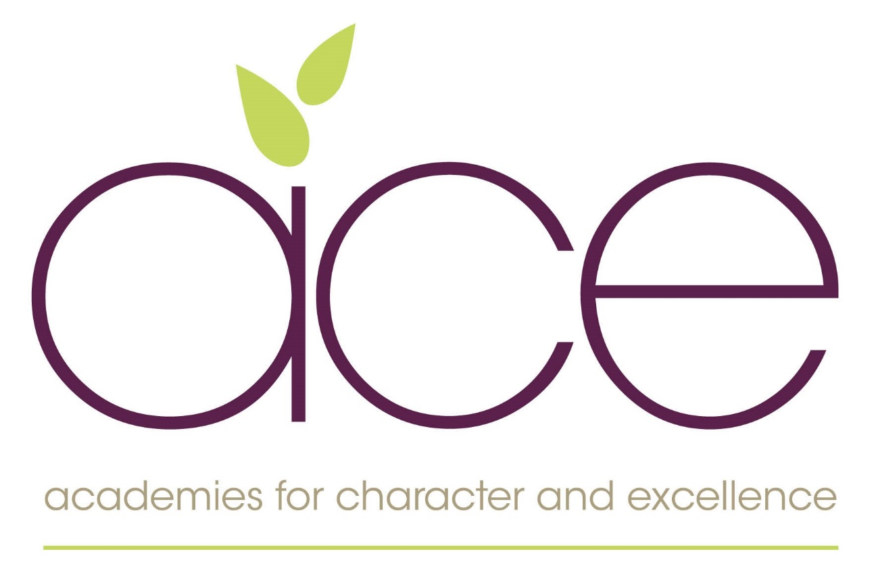

Positive Behaviour and Relationships Policy

Reference: Safeguarding


Policy date | February 2024 | Statutory Policy – Yes
Strategic Board Approval | February 2024
Reviewed and Updated

Next Review Date | February 2026 | Review cycle every 2 years
Author | WP/KB/JC | www.acexcellence.co.uk

Contents
1. Positive Behaviours and Relationships in ACE Schools
- Context : Ace Vision and Curriculum
- Purpose
- Policy Aims
- Underpinning Principles
2. Legislation and Statutory Requirements
3. Roles and Responsibilities
4. Definitions
5. Expectations for Behaviour
6. Incentives, Rewards and Consequences
7. Supporting Positive Behaviour
- Pupil Support
- Safer Handling
8. Monitoring Arrangements
9. Links with Other Policies

Appendix 1 – Our Approach to Securing Excellent behaviour and Relationships at Winsham Primary School
Appendix 2 – When behaviour becomes challenging – Our escalation plan
Appendix 3 – Rewards, Incentives and Privileges

Positive Behaviours and Relationships

1. Introduction and Context

Context: The Academies for Character and Excellence – Vision, Values and Curriculum

The approach we take to promoting Positive Behaviours and Relationships is anchored in the Trust’s vision, values and curriculum.

The Trust’s vision aspires to excellence in everything that we do in school, and how this is achieved through cultivating character, sharing talents and pursuing innovation. Supporting positive behaviours and relationships is directly shaped through this – be it through our programme of character education, through how our staff within and across schools work together to continually improve the approach to positive behaviour, to how we positively embrace new approaches to help our pupils develop [discipline and self-control]. This is reinforced through the Trust’s values such as acting with integrity, equity and uncompromising excellence.

Our Curriculum focuses on achieving three main outcomes for our children, which are shown below:

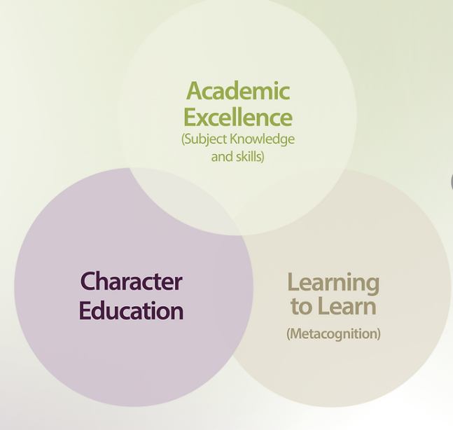
Positive behaviour and relationships are reinforced throughout the delivery of all three aspects of the curriculum. For example, by supporting pupils to develop character values – such as taking responsibility and supporting others, and through developing their metacognition (self-awareness and self-reflection).

The first stage in our approach to positive behaviour and relationships is therefore proactive: through teaching, modelling and experience, we want to ensure our children are able to develop self-discipline, and excellent behaviour and kindness to, and empathy of, others.

The remainder of this policy builds on the vision, values and curriculum implementation to help ensure that school is a happy and positive place for all pupils in our care.

Purpose
The purpose of this policy is to promote very positive behaviours and relationships between all members of our school with a view to:
- promoting, among pupils, relational awareness of themselves and others.
- promoting self-discipline and an understanding of the need for rules.
- encouraging excellent behaviour and respect for others on the part of pupils and, in particular, preventing all forms of bullying among pupils.

Policy Aims
As part of our ACE approach to promoting positive behaviours, we believe that teaching children to regulate their own behaviour MUST start with pursuing positive relationships. We believe this is a more constructive approach than a system of sanctions and punishments. We also believe that our ongoing work around character will develop our pupils’ ability to develop those mutually respecting relationships. We aim to focus on solutions rather than problems.
Our approach to positive behaviour follows that of the Church of England Education Office, in that it seeks to be faith-sensitive and inclusive. It is under-pinned by our school vision of “One community where we cultivate, grow and flourish together.” and ensures that all of school life incorporates the values of the Christian Faith.

These values are central to all that we do and determine how we will implement all policies and procedures. We want to ensure that through our gateways of Citizenship, Leadership, Expression, Exploration and Flourishing, all pupils and adults are shown how to be Compassionate, Forgiving, Determined and Honest individuals, who act with integrity and responsibility. By starting with our vision, we aim to ensure that all members of our school community understand our expectations, our practice and the ways in which we will implement policy. This policy therefore aims to:
- Provide a consistent approach to behaviour management and secure very positive relationships for all
- Define what we consider to be unacceptable behaviour, including bullying
- Outline how pupils are expected to behave and relate to others
- Summarise the roles and responsibilities of different people in the school community with regards to behaviour management
- Outline our system of incentives and consequences.
Underpinning Principles:
Delivery of this policy is underpinned by our collective understanding that:
- all behaviour is communication, and we need to be diagnostic in the quest to support our pupils to demonstrate excellent behaviour
- the most effective way of securing excellent behaviour comes as a result of trusting, respectful and connected relationships
- meaningful relationships build self-esteem and develop our sense of belonging. We aim in this policy to create a simple and effective system and recognise the importance of our work around Character education and metacognition
- restorative practice supports positive interactions among all, by using effective language, remaining non-judgemental and encouraging everyone to speak using restorative questions and restorative conversations
- it is important to embrace and embed best practice in how we support children’s growth, including providing opportunities to build communication skills, confidence, resilience and independence
- an effective partnership between parents/carers and the school is vital in order to ensure the causes of – and potential solutions to – challenging behaviour can be collectively identified

- the delivery of this policy in our school will be more effective if it is informed by input from pupils, staff, parents and wider stakeholders.

2. Legislation and statutory requirements
This policy is informed by the following key documents:
- Our ACE curriculum document including our outcomes for all pupils
- Behaviour and Discipline in Schools
- The Equality Act 2010
- Use of Reasonable Force in Schools
- Supporting Pupils with Medical Conditions at School
It is also based on the Special Educational Needs and Disability (SEND) Code of Practice.
In addition, this policy is based on:
- Schedule 1 of the Education (Independent School Standards) Regulations 2014: paragraph 7 outlines a school’s duty to safeguard and promote the welfare of children, paragraph 9 requires the school to have a written behaviour policy and paragraph 10 requires the school to have an anti-bullying strategy
- DfE guidance explaining that academies should publish their behaviour policy and anti-bullying strategy online. This policy complies with our funding agreement and articles of association.

3. Roles and responsibilities

The Headteacher
The Headteacher is responsible for preparing the school’s Positive Relationships and Behaviour Policy in consultation with the Trust’s Head of Safeguarding and Inclusion and the school’s Local Learning Committee. The Headteacher will ensure a copy of the policy is placed on the school’s website and is available on request.
The Headteacher is responsible for ensuring the effective implementation of the policy in their setting. This will include ensuring a school culture and environment that actively encourages positive relationships and excellent behaviour. They will support staff to do this effectively, including monitoring to ensure that rewards and consequences are applied consistently.

Staff
All staff in the school are responsible for:
- Ensuring they are fully aware of the behaviour policy and for implementing it consistently at all times in school
- Modelling positive relationships and behaviour
- Supporting the development and implementation of personalised approaches to enable children with specific behavioural needs to meet the expectations set out in this policy
- Recording behaviour incidents in the school’s behaviour log (and on MY Concern for anything more than very minor disciplinary measures (such as basic reprimands/warnings).
The senior leadership team will support staff in responding to behaviour incidents.

Parents and Carers
Parents are expected to:
- Support their child in adhering to this policy
- Inform the school of any changes in circumstances that may affect their child’s behaviour
- Discuss any behavioural concerns with the class teacher promptly and work in partnership with the school to support their child to succeed.

The Local Committee/Local Learning Committee
The Local Committee is responsible for monitoring the policy’s effectiveness and holding the headteacher to account for its implementation.

The ACE Board and Central Team
The ACE Board is responsible for oversight of all schools in the Trust, including compliance with legal and statutory requirements in relation to behaviour (including safeguarding and SEND). The ACE Central Team supports the Headteacher in the implementation of the behaviour policy through provision of specialist advice, guidance and resources.

4. Definitions
Unacceptable behaviour is defined as:
- Disruption in lessons, in corridors between lessons, and at break and lunchtimes
- Non-completion of classwork when reminders are given
- Unkind and inconsiderate behaviour to others
- Repeated breaches of the school rules
- Any form of bullying (see below)
- Sexual or physical assault, which is any unwanted sexual behaviour that causes humiliation, pain, fear or intimidation
- Vandalism
- Theft
- Fighting
- Racist, sexist, homophobic or discriminatory behaviour
- Possession of any prohibited items such as inappropriate materials, alcohol or drugs
- Possession of any article a staff member reasonably suspects has been – or is likely to be – used to commit an offence, or to cause personal injury to or damage to the property of any person (including the pupil).
(This is not an exhaustive list.)

Bullying is defined as the repetitive, intentional harming of one person or group by another person or group, where the relationship involves an imbalance of power.
Bullying is, therefore:
- Deliberately hurtful
- Repeated, often over a period of time
- Difficult to defend against.
More detail to the school’s approach to bullying is set out in our Anti-Bullying Statement, which is available on the school website.

5. Expectations for pupil behaviour across ACE schools
Pupils are expected to:
- Put into practice our gateway values and exemplify these in all that they do, including seeking to develop positive relationships with their peers and adults in school
- Behave in a compassionate and self-controlled way
- Show good manners to others and an increasing drive to take responsibility for their own actions
- In class, make it possible for all pupils to learn independently and collaboratively
- Move safely and responsibly around the school
- Treat the school buildings and school property with care and respect
- Wear the school uniform and be proud to do so
- Accept consequences when given and reflect on behaviour during restorative sessions
- Increasingly become aware of their own behaviour and develop strategies that will have long-term benefits for themselves and others.

6. Incentives, rewards and consequences
All ACE schools share the same principles around the securing of excellent behaviours and relationships. However, specific approaches taken in each individual school are tailored to reflect the different contexts and inputs from pupils and staff on how excellent behaviour and relationships will be achieved in Winsham Primary School. We use a variety of approaches to:
- Raise self-esteem and confidence
- Recognise and reward good and improving behaviour
- Reinforce and maintain good behaviour
- Motivate students to engage and participate
- Modify behaviour
- Incentivise achievement
- Develop relationships and pro-social behaviours and problem-solving skills
- Develop resilience and independence.
At the end of this policy you will find details of the specific approaches we use at Winsham Primary School including:
Appendix 1 – Securing excellent behaviour at Winsham Primary School
Appendix 2 – When behaviour becomes challenging: our escalation plan
Appendix 3 – Rewards and incentives

7. Supporting Positive Behaviours
Pupil Support
We have the same high expectations of behaviour for all pupils in our school community. However, we recognise that some children with specific needs will require additional support to be successful in this regard. The teacher, working with the SENDCo and other adult support as appropriate, will work with the child and parents/carers to put measures in place to do this, and due adjustments to the application of the behaviour policy will be made where it is appropriate for individual pupils’ needs.

Safer Handling
On very rare occasions and where all other approaches have been utilised, staff may use reasonable force to restrain a pupil to prevent them:
- Causing disorder
- Hurting themselves or others
- Damaging property
- Being unsafe/putting themselves or others in danger.

Incidents of physical restraint must:
- Always be used as a last resort
- Be applied using the minimum amount of force and for the minimum amount of time possible
- Be used in a way that maintains the safety and dignity of all concerned
- Never be used as a form of punishment
- Be recorded and reported to parents as soon as possible.

8. Monitoring arrangements
A Trust-wide Positive Relationships and Behaviour policy will be updated every two years by the ACE Central Team and approved by the ACE Board. This will be reviewed by the Headteacher, in consultation with their local committee, to ensure it is then appropriately tailored for the school’s context and to reflect specific procedures for behaviour in that setting.

9. Links with other policies
This behaviour policy is linked to the following policies and documents:
- ACE curriculum documents (EYFS/Disadvantaged/Nine Essentials)
- ACE: Developing Depth and Progression
- ACE Safeguarding and Child Protection policy
- ACE Exclusions policy
- ACE mobile phone policy. (This policy highlights that children bringing mobile phones into school should hand these into the school office on arrival at school. The phone will be returned to the child at the end of the school day. Children are not allowed to use mobile phones in school.)

Appendix 1– Our Approach to Securing Excellent Behaviour and Relationships at Winsham
Winsham Golden Rule | Pupils will… | Adults will… | Which enables… | And prevents… | This will be celebrated by… | This may be escalated when…
Be respectful | - Speak politely and considerately to others  - Be respectful of their own property and that of others  - Treat the school environment with respect by taking care and pride in it  - Respect the viewpoints of others | - Remind children to use a courteous voice  - Always remain calm  - Be the most respectful themselves so that this can be modelled to children | - Mutually respecting relationships  - An appreciated and productive environment  - A safe place to share views and differences  - An understanding that speaking respectfully is the best way of communicating | - A lack of consideration for others  - Untidy and unsafe environments  - Unhealthy disagreements  - Intolerance of others  - An inability to listen and understand others  - Bad manners | - Recognition, highlighting the behaviours you want to see  - Verbal praise  - Stickers, certificates  - A place on the lunchtime golden table  - Selecting children to represent the school and carry out additional responsibilities | - The lack of respect results in harm, verbally or physically, to another person  - The school environment or resources are deliberately destroyed or spoilt
Be a role model | - Walk around the school quietly  - Model the school rules and behaviours we want to others  - Demonstrate integrity to others  - Display good manners | - Be a good role model themselves  - Draw attention to pupils who are good role models, highlighting their behaviour  - Use consistent language  - Deliberately pair/group children with role models | - All children to understand behaviour expectations  - All to see what it should look like  - A standard that is set and which all children should aspire to  - Ease of transitions and more unstructured parts of the day | - Any confusion around expectations  - Younger children feeling unsupported  - Less well- developed relationships between different year groups | - Highlighting great role models  - Use of certificates  - Developing older children to model and support behaviours e.g. EYFS/Y6 buddy system | - Children are consistently not providing a good role model to others (see escalation section)
Be ready | - Be on time  - Have the correct resources ready  - Be in the right place  at the right time  - Have the correct uniform/kit on | - Always be ready themselves  - Modelling excellent organisational skills  - Ensure the whole class arrives on time for set parts of the day | - Effective use of time across the day  - Maximum learning time  - Sense of orderliness  - Sense of calm and purposefulness | - Wasted learning time  - A negative impact on others  - A calmer environment because there is no rushing  - A frenetic atmosphere | - Incentives and privileges e.g. leading the line  - Praise for being ready  - Highlighting of child as role model  - Additional responsibilities and recognition of effort | - We recognise that for some children, they receive poor role models from home  - Teachers need to have a conversation with parents to see how we can find solutions together
Be reliable | - By entering the school after playtimes silently  - By ensuring you are in the right place, at the right time, doing the right thing | - Be consistent in their expectations, in their language and in the following of this policy  - Always accentuate the positive, especially for those who struggle more | - Optimal conditions for learning  - Children feeling secure and safe in school  - Understanding of routines and rules  - Independence and dependence  - Developed sense of self and self-control | - A lack of trust  - Lack of contact time and wasted time  - Power struggles  - Poor relationships | - Verbal feedback (self-fulfilling prophecy)  - Incentives for the individual and whole class  - Messages to parents  - HT certificates and other classroom rewards | - When a lack of reliability escalates into challenging behaviours and impacts on individual learning and the learning of others
Be responsible | - Accept when things have gone wrong  - Be honest  - Solve problems for themselves  - Take pride in what they have achieved | - Model and highlight responsibility in action  - Not overly support children when they have the ability to be independent  - Practise responsibilities  - Build on small successes | - Independence/confidence  - Develops problem-solvers  - Encourages children to be self- sufficient  - Enables greater efficiencies across the school for children and adults | - The over-reliance on adults to support when child should be able to manage on own  - Low self-esteem  - Inability to forge good relationships | - Leadership roles in schools e.g. Y6 play leaders  - HT certificates: the highlighting of excellent examples  - Class rewards – the marble jar | - When pupils are refusing to accept responsibility  - Where this impacts on other areas of school life  - Where others are being affected

Appendix 2 – When Behaviour Becomes Challenging – Our Escalation Plan

We use an eight-step approach to manage and modify behaviour that does not reflect our five golden rules:

Steps |  | Action
1 | Reminder | A reminder of the school’s behaviour ladder, referring/pointing to the display. Clearly state the behaviours you wish to see.  If the behaviour continues move to step 2.  If the behaviours displayed are those deemed as requiring an ‘Immediate response’ (see below), move directly to step 3, ‘Time with’.
2 | Redirection &  Caution | Make a change of place, activity, task or person. A clear verbal caution (delivered discreetly wherever possible), making the learner aware of the behaviour that has warranted redirection. Openly outline the consequences if they continue but also make it clear as to how they can turn the situation around.  If the behaviour continues move to step 3.
3 | Time with  (an adult who has been dealing with the behaviour escalation) | Speak to the learner privately for five minutes during their break or lunch time. This must be logged in the ‘time with’ book. Be curious and diagnostic in the approach, validating the child’s experience but also be clear on expectations and ways in which their behaviour can be modified.  If the behaviour continues move to step 4.
4 | Phone call (class teacher) | Should the learner persist with the unwanted behaviour/if the same pupil has had ‘time with’ 3 or more times in a week, a phone call to parents/carers is made so that they are aware of the behaviours being seen at school. Where relevant, the Headteacher may also be involved at this stage.  If the behaviour continues move to step 5.
5 | Formal meeting with class teacher | A face-to-face meeting is called with the pupil, parents/carers and teacher to discuss strategies for transforming the behaviour. Impact will be monitored for at least two weeks.  If the behaviour continues move to step 6.  A meeting may also be called for a serious breach of the school rules as detailed in the ‘Immediate response’ section below. A member of SLT may be involved in this meeting where necessary.
6 | Behaviour support plan introduced | Another meeting with the parents/carers is held promptly and a behaviour support plan implemented. The relevant KS Leader will be involved in this meeting and the SENCo will have been consulted. Where appropriate the Headteacher may also be involved in this meeting.
7 | Internal exclusion | An internal exclusion is issued and carried out by the Headteacher as a consequence for a serious or persistent breach in behavioural expectations such as those outlined in the ‘Immediate response’ section below.
8 | Fixed Term exclusion | The Head of School excludes a pupil from the school for a fixed period of time. Before taking such a step the Head of School will have taken advice from the Trust’s Head of Safeguarding and Inclusion.
8 | Permanent exclusion | The Head of School excludes a pupil permanently. Before taking such a step the Head of School will have taken advice from the Trust’s Head of Safeguarding and Inclusion and relevant external agencies. Formal approval from the Trust CEO must be sought for any permanent exclusion.
Immediate response situations |  | An immediate response is necessary when certain serious misbehaviour has occurred towards pupils and adults, such as:  • Bullying  • Derogatory behaviour such as racist, homophobic or non-inclusive  • Bad language directed at another person  • Defiance  • Damaging property  • Hurting others with deliberate intent  In these cases, the incident will immediately be reported to SLT and recorded/logged, and an appropriate action taken. A phone call home will automatically take place and in some instances, a face-to-face meeting may be called.

Appendix 3 – Rewards, Incentives and Privileges

Although we recognise that the use of over-praising can be counterproductive, we do want to accentuate positive behaviour and develop excellent relationships with all our pupils. Positive behaviour and reinforcement is emphasised at all times. Praise is used to:
- Reinforce the rules as children learn more quickly when given positive feedback
- Reinforce and communicate our 5 ‘R’ golden rules
- Draw other children's attention to appropriate behaviour
- Give emphasis to the wanted behaviour, rather than the unwanted
- Encourage self-esteem and an ethos of friendly acceptance
- Encourage children to make choices so that they can see that good behaviour is rewarded

Whole-School Rewards | - *NEW :Headteacher’s award – two children are selected each half term.  - Verbal praise and stickers.  - Dojo Points which are earned individually but also for their teams.  - Peer awarded ‘Shout -outs’ for demonstrating our values.
Class Rewards and Privileges | At the beginning of the year, children agree what they will be rewarded for and what this will look like.  - Extra play time  - Golden time – children choose an activity of their choice  - Non-uniform day

