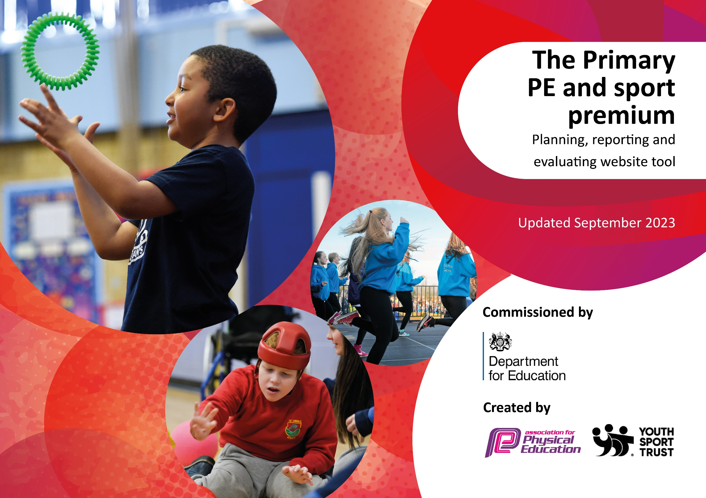

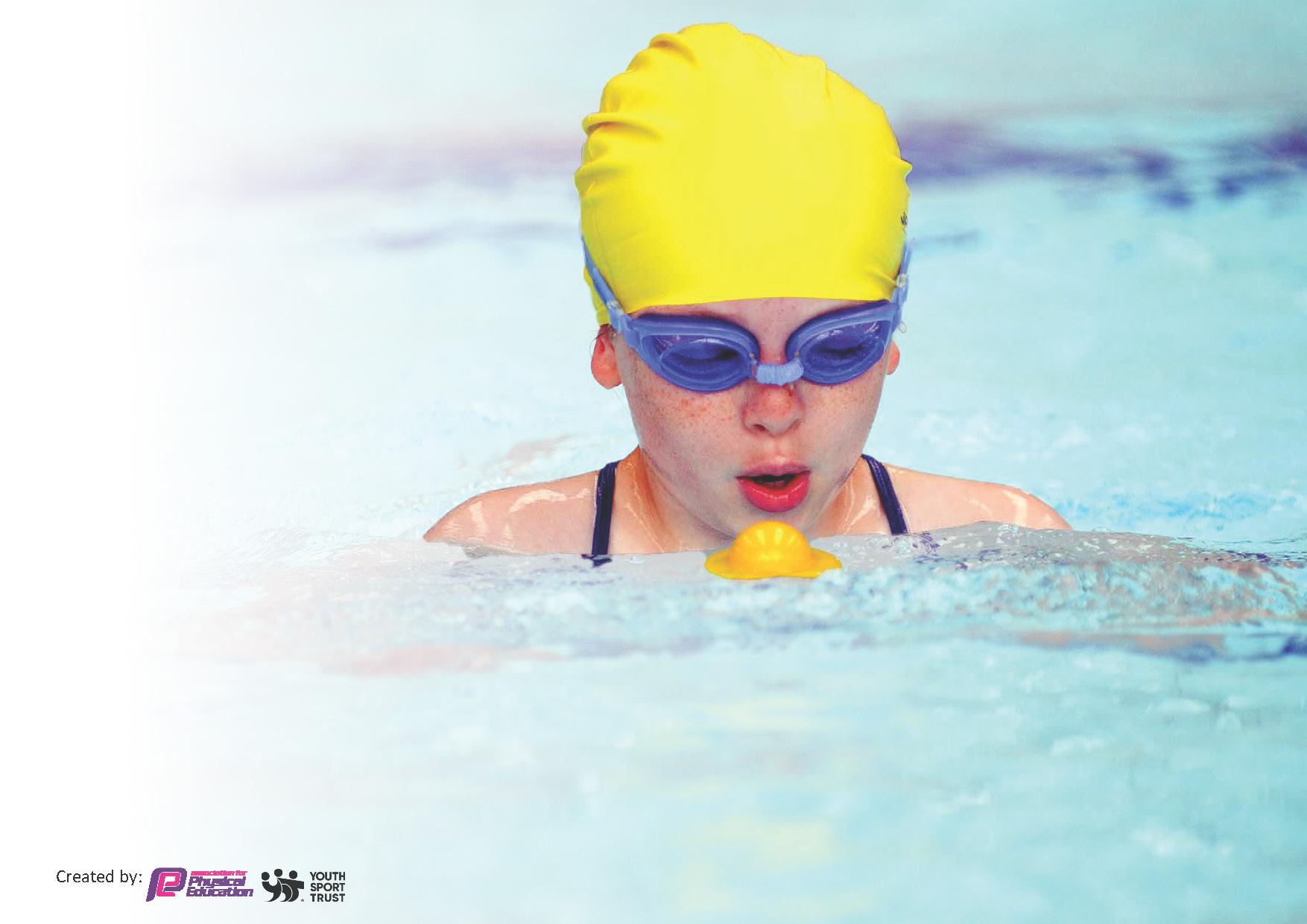
This template can be used for multiple purposes:
by:
- It enables schools to effectively plan their use of the Primary PE and sport premium
- It helps schools to meet the requirements (as set out in guidance) to publish information on their Primary PE and sport premium
- It will be an effective document to support Ofsted inspections enabling schools to evidence progress in Physical Education (PE) and evidence swimming attainment, which forms part of the PE National Curriculum. We would recommend schools consider
the Intent, Implementation and Impact of any spend, as examined within the Education Inspection Framework.

It is important that your grant is used effectively and based on school need.

Schools must use the funding to make additional and sustainable
improvements to the quality of the PE, School Sport and Physical Activity (PESSPA)
they offer. This means that you should use the Primary PE and sport premium to:

- Build capacity and capability within the school to ensure that improvements made now will benefit pupils joining the school in future years
- Develop or add to the PESSPA activities that your school already offers.

The Primary PE and sport premium should not be used to fund capital spend projects; the school’s core budget should fund these. Further detail on capital expenditure can be found in the updated Primary PE and sport premium guidance.

The Primary PE and sport premium guidance, outlines 5 key priorities that funding should be used towards. It is not

necessary that spending has to meet all the key priorities, you should select the priorities that you aim to use any funding towards.

Although completing this template is not a requirement for schools, schools are required to publish details of how they spend this funding. Schools must also outline what the impact this funding has had on pupils’ PE and sport participation and attainment and how any spending will be sustainable in the future. All funding must be spent by 31st July 2024.

The Department for Education has worked closely with the Association for Physical Education (afPE) and the Youth Sport Trust (YST) to develop this template and encourages schools to use it. This template is an effective way of meeting the reporting requirements of the Primary PE and sport premium.
Review of last year’s spend and key achievements (2023/2024)

We recommend you start by reflecting on the impact of current provision and reviewing your previous spend.

Activity/Action | Impact | Comments
- PE delivery is developed well.  - Forest School is an area for improvement.  - After school club. | Children have a wide range of sports skills.  Good progress is being made in character development, specifically collaboration and resilience.  More children are attending this club weekly. | Continue to embed next year.  Further opportunities need including across the week.  Expand opportunities further next year.

Key priorities and Planning
This planning template will allow schools to accurately plan their spending.

Action – what are you planning to do | Who does this action impact? | Key indicator to meet | Impacts and how sustainability will be achieved? | Cost linked to the action
Introduce new lunchtime activities to encourage less active children to take part (using Sport Leaders). | Teaching assistants / lunchtime supervisors, Forest school leads - as they need to lead/oversee the activity.  Pupils – as they will take part and the play leaders will lead/organise the activities/equipment. | Key indicator 2 -The engagement of all pupils in regular physical activity – the Chief Medical Officer guidelines recommend that all children and young people aged 5 to 18 engage in at least 60 minutes of physical activity per day, of which 30 minutes should be in school.  Key indicator 4: Broader experience of a range of sports and activities offered to all pupils. | More pupils meeting their daily physical activity goal, more pupils encouraged to take part in PE and Sport Activities.  Pupils are using their leadership skills to help organise and run whole school activity. Sport leaders train next year’s sports leaders | £4410

CPD for teaching assistant and pupils to become Sports leader and assistants delivered through Sports coaches of Premier Sports | Primary teaching assistant to become Sports Lead  Pupils to be play and lunch assistant sports leaders. | Key Indicator 1: Increased confidence, knowledge, and skills of new Sports Lead in teaching PE and sport.  Key indicator 5: Increased participation in competitive sport. | Teaching assistants to become Sports Lead - more confident to deliver effective PE supporting pupils to undertake extra activities inside and outside of school and as a result improved % of pupil’s attainment in PE. | £2613
Continue to offer a wider range of activities both within and outside the curriculum in order to get more pupils involved. | Forest School Sessions for all pupils half a day a week by trained Forest School Leader.  Forest School pre-school session offered weekly. | Key indicator 4: Broader experience of a range of sports and activities offered to all pupils. | Children given the opportunity to engage in new experiences  Children active in nature and encouraged to send more time outside. | £6727
Increase the number of extracurricular clubs offered to widen the appeal for all children | Children engaging in more activities after school. Aim for a club on offer 3 nights after school. | Key indicator 4: Broader experience of a range of sports and activities offered to all pupils. | Staff are committed to contributing to school life outside of the school classroom and this will encourage expansion of after school clubs. | £1470
To share and celebrate sports achievements and leadership across the school to inspire others to achieve. | Sports News celebrated in the newsletter, school Facebook page and School Games website. Fixtures, results or individual achievements outside school to be shared via the school Facebook page and in celebration assembly. | Key indicator 3: The profile of PE and sport is being raised across the school as a tool for whole school improvement | Profile of sport raised across the school and embedded into school practice | No cost
Provide an appropriate plan to improve sports/play equipment for staff to plan with, so all pupils can participate and engage in a range sporting experiences. | Identify needs for further equipment required through the curriculum plan.  • Order equipment to ensure suitable equipment is in place for extracurricular clubs and curriculum PE.  • Order playtime equipment to ensure children are active during lunchtimes and have suitable equipment for lunchtime clubs.  • Complete school inventory of equipment in the school | Key Indicator 1: Increased confidence, knowledge, and skills of new Sports Lead in teaching PE and sport.  Key indicator 2 -The engagement of all pupils in regular physical activity – the Chief Medical Officer guidelines recommend that all children and young people aged 5 to 18 engage in at least 60 minutes of physical activity per day, of which 30 minutes should be in school.  Key indicator 4: Broader experience of a range of sports and activities offered to all pupils.  Key indicator 5: Increased participation in competitive sport. | Playground equipment is regularly resourced to ensure there is a wide range of play resources. | £1000

Key achievements 2024-2025
This template will be completed at the end of the academic year and will showcase the key achievements schools have made with their Primary PE and sport premium spending.

Activity/Action | Impact | Comments
- Teaching assistants skilled at delivering and assisting PE.  - Forest school is offered weekly for both classes and Nursery children.  - Increased play and lunch activities. | Children are involved in more physical activity across the week.  All children across the school have increased opportunity for character development.  All children have increased opportunities to access physical activities. | Further sessions of PE can now be offered across the week. However changing staff will require further CPD next year  Continue to embed and develop next year, change of Forest school lead will require further CPD.  Again, due to change of staff further training and development will be needed next year.

Swimming Data
Meeting National Curriculum requirements for swimming and water safety 2024-25.
Priority should always be given to ensuring that pupils can perform safe self-rescue even if they do not fully meet the first two requirements of the National Curriculum programme of study – NB: This template will be completed at the end of the academic year.

Question | Stats: | Further context  Relative to local challenges
What percentage of your current Year 6 cohort can swim competently, confidently and proficiently over a distance of at least 25 metres? | 75%  (3 out of 4) | One new to us child had not learned to swim prior to joining us in year 6.
What percentage of your current Year 6 cohort can use a range of strokes effectively [for example, front crawl, backstroke, and breaststroke]? | 75%  (3 out of 4)

What percentage of your current Year 6 cohort are able to perform safe self-rescue in different water-based situations? | 75%  (3 out of 4)
If your schools swimming data is below national expectation, you can choose to use the Primary PE and sport premium to provide additional top-up sessions for those pupils that did not meet National Curriculum  requirements after the completion of core lessons. Have you done this? | No
Have you provided CPD to improve the knowledge and confidence of staff to be able to teach swimming and water safety? | Yes | Swimming is taught by qualified instructors at Chard swimming pool.  Teacher and teaching assistant have attended lessons to gain CPD.

Signed off by:

Head Teacher: | Tina Legg
Subject Leader or the individual responsible for the Primary PE and sport premium: | Tina Legg
Governor: | With Governors TBC
Date: | 31st July 2025

