
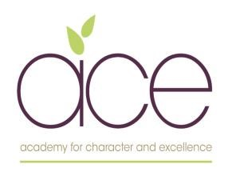

Author | T Legg
Religious and worldviews Education Policy
Policy date | October 2022
Reviewed and Updated | November 2024
Next Review Date | November 2026

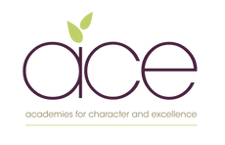

One community where we cultivate, grow and flourish together.

Winsham Primary School will provide a happy, caring, family environment where children feel inspired. Our aim is to ensure that each and every child achieves and flourishes within our committed church school community. Belonging to a safe and nurturing community, founded on strong Christian values, we hope that children will develop an array of skills that will equip them to meet the challenges or our everchanging world and to make their own positive contribution to our global society.

1) The Legal Position

Religious Education is unique in the school curriculum in that it is neither a core subject nor a foundation subject but the 1988 Education Act states that ‘Religious Education has equal standing in relation to core subjects of the National Curriculum in that it is compulsory for all registered pupils’

Winsham Primary School is a Church of England School therefore the provision of RE must be in accordance with the Trust Deed of the School. The Local Authority Boards (LAB) members in consultation with the Head of School have decided, following advice from the diocese, to adopt the Locally Agreed Syllabus, and supplement this with material from the Diocese and elsewhere.

2) Rationale and Aims
In Religious Education at Galmpton School and as a Church school we aim that Religious Education will:-

- To enable pupils to know about and understand Christianity as a living faith that influences the lives of people worldwide and as the religion that has most shaped British culture and heritage.
- provoke challenging questions about the meaning and purpose of life, beliefs, the self, issues of right and wrong, and what it means to be human. It develops pupils’ knowledge and understanding of Christianity, other principal religions, and religious traditions that examine these questions, fostering personal reflection and spiritual development
- encourage pupils to explore their own beliefs (whether they are religious or non-religious), in the light of what they learn, as they examine issues of religious belief and faith and how these impact on personal, institutional and social ethics; and to express their responses. This also builds resilience to anti-democratic or extremist narratives.
- enable pupils to build their sense of identity and belonging, which helps them flourish within their communities and as citizens in a diverse society
- teach pupils to develop respect for others, including people with different faiths and beliefs, and helps to challenge prejudice
- prompt pupils to consider their responsibilities to themselves and to others, and to explore how they might contribute to their communities and to wider society.
- It encourages empathy, generosity and compassion and develops a sense of awe and wonder and mystery

3) The contribution R.E. makes to other curriculum aims in particular to community cohesion

Spiritual, moral, social and cultural development
Section 78 (1) of the 2002 Education Act states that all pupils should follow a balanced and broadly based curriculum which ‘promotes the spiritual, moral, social, cultural, mental and physical development of pupils and of society, and prepares pupils for the opportunities, responsibilities and experiences of later life’. Learning about and from religions and beliefs, through the distinct knowledge, understanding and skills contained in RE within a broad-based curriculum, is essential to achieving these aims. Exploring the concepts of religion and belief and their roles in the spiritual, moral and cultural lives of people in a diverse society helps individuals develop moral awareness and social understanding.

Personal development and well-being
R.E. plays an important role in preparing pupils for adult life, employment and lifelong learning. It helps children and young people become successful learners, confident individuals and responsible citizens. It gives them the knowledge, skills and understanding to discern and value truth and goodness, strengthening their capacity for making moral judgements and for evaluating different types of commitment to make positive and healthy choices.

Effective teaching and learning about Religions and World Views
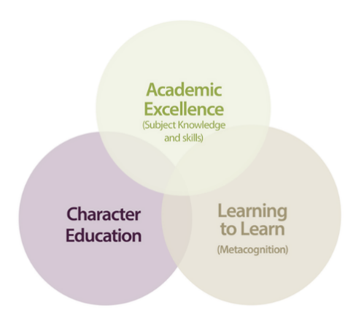
We believe that excellent RWE teaching should involve the development of both character values and learning to learn (metacognition skills) alongside subject knowledge and skills. Throughout our RWE learning enquiries, we seek frequent opportunities to reflect and develop our metacognitive approach.
Through this interweaving of subject knowledge, character education and metacognition, learners are provided with opportunities to understand the world around them, and how their own beliefs and values shape their worldviews.
Our learning enquiries follow the same format in terms of planning and delivery of lessons. We use our RWE lessons to develop independent, creative and collaborative learners who are able to disagree respectfully and view their RWE learning through a number of lenses. (philosophically, theologically and socially)

Church schools have a duty to provide accurate knowledge and understanding of religions and world views. They should provide:
A challenging and robust curriculum based on an accurate theological framework.
An assessment process which has rigour and demonstrates progression based on knowledge and understanding of core religious concepts.
A curriculum that draws on the richness and diversity of religious experience worldwide.
A pedagogy that instils respect for different views and interpretations; and, in which real dialogue and theological enquiry takes place.
The opportunity for pupils to deepen their understanding of the religion and world views as lived by believers.
RE that makes a positive contribution to SMSC development

4) The school’s approach to teaching R.E.

R.E. has an important part to play as part of a broad, balanced and coherent curriculum to which all pupils are entitled. High quality learning experiences in RE are designed and provided by careful planning through locally agreed syllabuses, (diocesan advice) and in schools, taking into account the need to offer breadth of content.

In order to make religious education a lively, active subject we employ a variety of teaching methods including art, music, discussion, the development of thinking skills, drama, the use of artefacts, pictures, stories, and the use of periods of stillness and reflection.
Where possible we want our pupils to have opportunities to encounter local faith communities through visits to local places of worship or visits from members of local faith communities.

Religious Education at Winsham Primary School is delivered in the following way:

We use as a basis for our planning the AMV Somerset Agreed Syllabus for Religious Education 2012 supplemented with, and supported by, other ideas including the Devon And Torbay syllabus which our Devon Trusts schools use.

5) How R.E. is organised-Curriculum balance

Christianity should be the majority study in RE in every school. In Church schools that should be clearly adhered to. In Key Stages 1 – 3 at least 2/3rds of RE teaching should be Christianity. Sufficient dedicated curriculum time, meeting explicitly RE objectives, however organised, should be committed to the delivery of RE. This should aim to be close to 10% but must be no less than 5%.

The Foundation Stage
During the foundation stage, children begin to explore the world of religion in terms of special people, books, times, places and objects, visiting places of worship and through celebration. Children listen to and talk about stories. They are introduced to specialist words and use their senses in exploring religious beliefs, practices and forms of expression. They reflect upon their own feelings and experiences. They use their imagination and curiosity to develop their appreciation and wonder of the world in which they live. The contribution of religious education to the early learning goals The early learning goals set out what most children should achieve by the end of the foundation stage.

R.E. is taught weekly as a specific subject – in accordance with diocesan plans. Every effort is made to link the areas covered by the Agreed Syllabus to the curriculum topics taught, or with other areas of school life including worship / PSHE.

In accordance with the structure of the locally agreed syllabus we have agreed that

In KS1
Enquiries take the form of a key question followed by a series of supplementary questions which provide the structure and direction of the individual enquiry. Together the enquiries are designed to engage pupils in both learning about and from religions and worldviews. The characteristics of learning highlight the key features of RE at key stage 1 and the experiences/opportunities provide guidance on the kinds of learning experiences children at key stage 1 should encounter. At key stage 1 pupils should study Christianity and one other religion and include other worldviews.

In KS2
These enquiries have been shaped to form a key question followed by a series of supplementary questions which provide the focus and structure for each enquiry. The emphasis is on developing the skills of investigation and enquiry and effectively engaging pupils in their learning in RE. The characteristics of learning highlight the essence of RE in key stage 2 and the experiences/opportunities provide guidance on the types of learning encouraged for key stage 2 children. At key stage 2 children should study, in a more systematic way, Christianity, Hinduism, Judaism and Islam and non-religious worldviews such as Humanism.

Resources for R.E. are kept in the staff room and specific resources are ordered to support areas from the resources library to which the schools pays an annual subscription.

An Enquiry Approach to Religious Education

It is intended that teachers will be creative and imaginative and develop their own approaches based on the agreed syllabus model, providing pupils with the opportunity to be involved in the planning and scope of their learning. Teachers are encouraged to plan with local faith and belief communities in mind and recognise the role they can play in providing examples of rich heritage and the diversity of faith, belief and ways of life. Pupils will be reminded that religion is globally and locally a vital and dynamic aspect of life and that they belong to a Devon community that is increasingly diverse. Enquiries are based
on the following key skills that pupils need to make progress with their learning in RE.

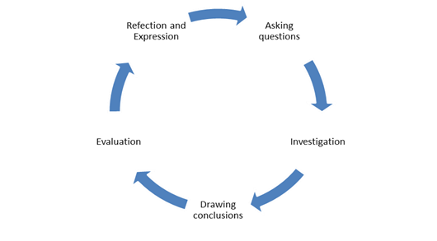

6) Assessment and Recording of RE

At the beginning and end of each unit of work, teachers will assess the children based on their work and contribution’s during class activities. Where relevant, an assessment task will be given.

7) Arrangements for monitoring standards of teaching and learning in RE

The subject lead will monitor RE within the school through analysis of this assessment data, through lesson observations, through work sampling and through pupil interviews.

This information will feed into the Church school self evaluation process. (SIAMS)

8) Responsibilities for RE within the school, (Head teachers and LAB members)

Developing staff expertise

To demonstrate the subject’s comparable status with other core curriculum areas in both staffing and resourcing, it should be a priority in Church schools to build up staff expertise in RE specifically but not exclusively, working towards:
- At least one member of staff having specialist RE training or qualifications.
- All staff teaching RE having access to appropriate professional development.
- All teaching staff and governors having an understanding of the distinctive role and purpose of RE within church schools.
- A governing body which monitors standards in RE effectively.

The role of the Diocesan Boards of Education
One function of Diocesan Boards of Boards of Education (DBEs) as set out in the DBE measure is to promote, or assist in the promotion of, RE in schools in the diocese. This can be fulfilled by:
Monitoring the quality of RE in church schools.
Offering high quality training to all schools throughout the diocese so that provision for RE is effective and promotes religious literacy.
Support for effective and outstanding RE

RE teachers belong to a wider educational and church community. They should expect positive support in providing effective and outstanding RE from:
- Their senior management team.
- Their governing body, especially Foundation governors.
- Their local Diocesan Board of Education, including a Schools’ Adviser with an appropriate RE background.
- Clergy.
- The Church of England Education Office (see Making a Difference p.31 no.4).
- The Church of England representatives on their local SACRE.

9) The right of Withdrawal from RE

At Winsham Primary School we wish to be an inclusive community but recognise that parents, of course, have the legal right to withdraw their children religious education on the grounds of conscience. However, the right of withdrawal does not extend to other areas of the curriculum when, as may happen on occasion, spontaneous questions on religious matters are raised by pupils or there are issues related to religion that arise in other subjects such as history or citizenship.
We would ask any parent considering this to contact the head teacher to discuss any concerns or anxieties about the policy, provision and practice of religious education at Galmpton Primary School.

Managing the right of withdrawal
- The school will ensure that parents who want to withdraw their children from RE are aware of the RE syllabus and that it is relevant to all pupils and respects their own personal beliefs.
- Parents should be made aware of its learning objectives and what is covered in the RE curriculum and should be given the opportunity to discuss this, if they wish.
- The school may also wish to review such a request each year, in discussion with the parents.
- The use of the right to withdraw should be at the instigation of parents (or pupils themselves if they are aged 18 or over), and it should be made clear whether it is from the whole of the subject or specific parts of it. No reasons need be given.
- Parents have the right to choose whether or not to withdraw their child from RE without influence from the school, although a school should ensure that parents or carers are informed of this right and are aware of the educational objectives and content of the RE syllabus. In this way, parents can make an informed decision.
- Where parents have requested that their child is withdrawn, their right must be respected, and where RE is integrated in the curriculum, the school will need to discuss the arrangements with the parents or carers to explore how the child’s withdrawal can be best accommodated.
- If pupils are withdrawn from RE, schools have a duty to supervise them, though not to provide additional teaching or to incur extra cost. Pupils will usually remain on school premises.
- Where a pupil has been withdrawn, the law provides for alternative arrangements to be made for RE of the kind the parent wants the pupil to receive. This RE could be provided at the school in question, or the pupil could be sent to another school where suitable RE is provided if this is reasonably convenient.
- If neither approach is practicable, outside arrangements can be made to provide the pupil with the kind of RE that the parent wants, and the pupil may be withdrawn from school for a reasonable period of time to allow them to attend this external RE.
- Outside arrangements for RE are allowed as long as the LA is satisfied that any interference with the pupil’s attendance at school resulting from the withdrawal will affect only the start or end of a school session.

Date of policy review: November 2024

Next renewal date: November 2026

